# REST Assignment Readme

**Common Steps TC** – This TC:

1. Gets the token.
2. Loads the token into Project Variable (From which all other test cases gets the token)
3. Logs in (Present in Setup of all TCs)
4. Logs Out (Present in Teardown of all TCs)

https://github.com/AranyaBiswas/RESTAssignment.git

## Project Structure –

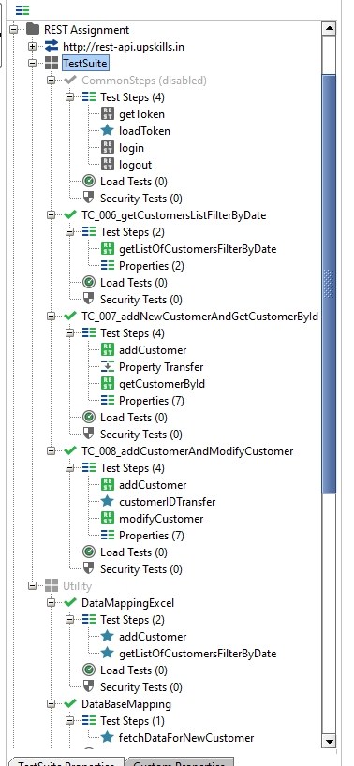

**TC08** – This TC fetches data from Properties. It Uses:

1. Properties is loaded using Excel File using Groovy Script.
2. Groovy Script to get details from Add customer which loads the response id into TC level variable
3. Assertions

**TC07** – This TC fetches data from Properties. It Uses:

1. Properties is loaded using MariaDB Database using Groovy Script.
2. Property Transfer
3. Assertions
4. Script Assertion

**TC06** – This TC fetches data from Properties. It uses:

1. Properties is loaded using Excel File using Groovy Script.
2. Assertions

**Utility Test Suite** – Disabled Test Suite That contains re-usable groovy scripts. Separated from the main Test Cases. Test Cases calls the groovy scripts from the respective test cases. (Using Setup & Teardown)

This has Scripts for:

1. CSV Reporting
2. Database Connection
3. Excel Connection

## Some points inside the Project –

1. Basic & Bearer Token is kept at project level and not hard coded into each and every test step. Separate Re suable Steps (Under Common steps TC) is present that is called by each and every tc to login and logout before a TC execution begins):

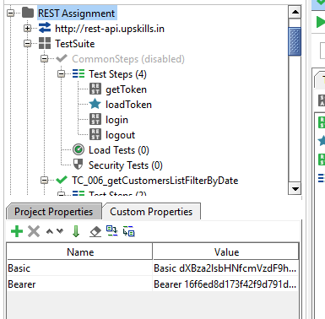

1. Assertions are present in test cases. Script Assertion present in TC 07 addCustomer

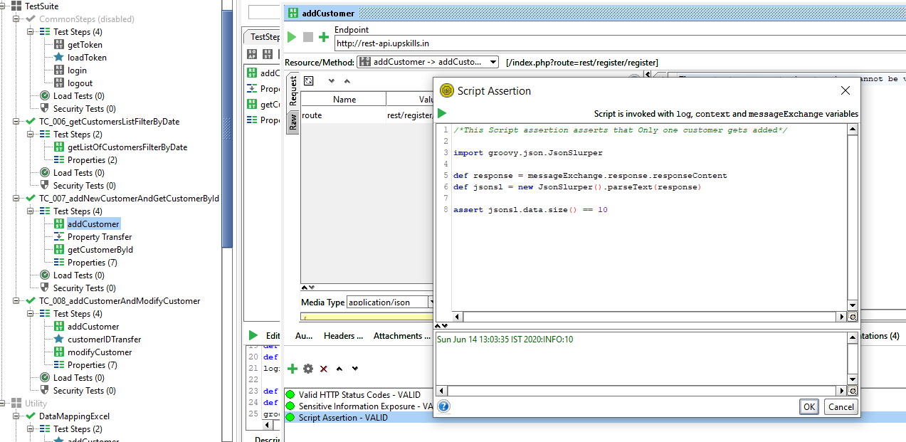

1. All Teardown Script in TCs call CSV Reporting feature & generates CSV Reports for all TCs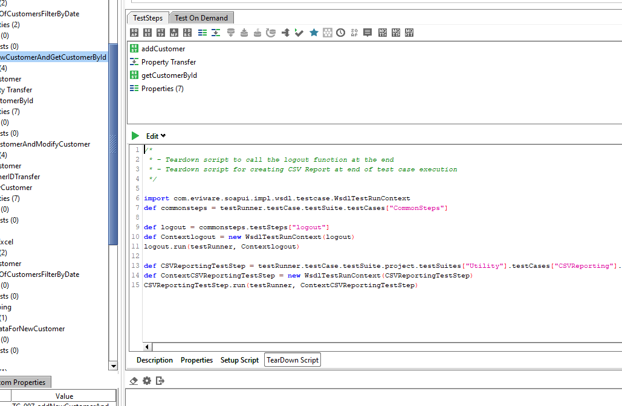
2. Excel File Path is not hardcoded into Groovy Scripts / any properties. The file resides into project path and is portable to any system. Groovy Script dynamically searches for the Project Path into host system & loads the excel from there.

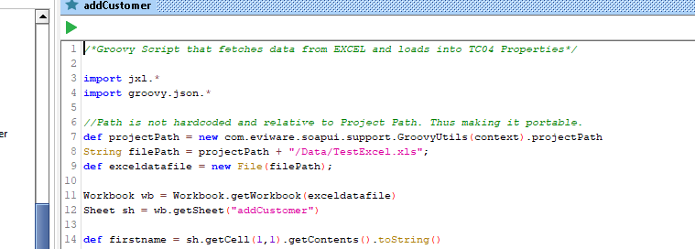

1. Database Connection is used by TC08: Following is the snapshot of DB used:

